ILMA CMS
Scheduled Payments & Payroll — Module Plan
Separating the free scheduling engine from the payout rail, and comparing payout options for Pakistan

1. Purpose
This document scopes a Scheduled Payments / Payroll feature for the Salary & Loan Management module. The key design point: scheduling and payout are two separate concerns with very different costs. Scheduling (when a payment is due) is pure application logic and free to build. Payout (actually moving the money) always runs over a paid rail — the choice is which rail, not whether to pay.

2. Two Concerns, Two Costs
Concern | What it is | Cost
Scheduling engine | A ScheduledPayment record plus a background job that checks daily for due payments and groups them into a batch. | Free — in-house application logic, no external dependency.
Payout rail | The actual transfer of money to each payee's bank/wallet account. | Always has some cost — the options in Section 4 differ in how much and how automated.

3. Data Model
New entities for the scheduling/payroll engine, attaching to the existing StaffMember and Branch entities from the core ERD.
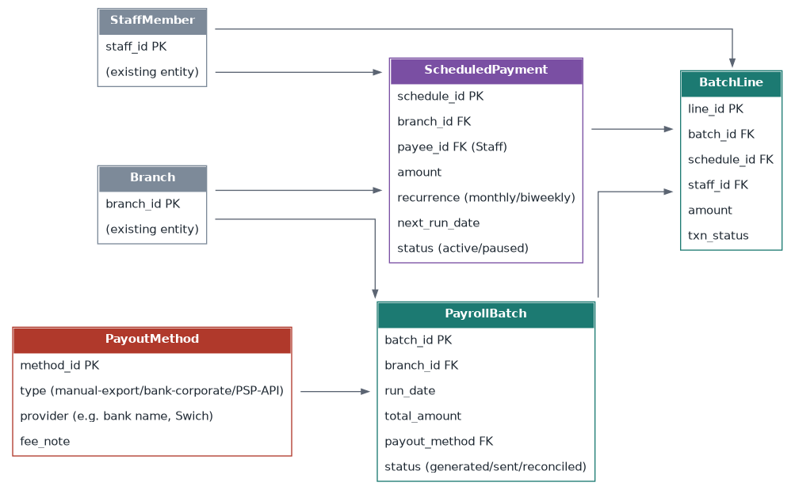
Figure 1 — ScheduledPayment generates PayrollBatch runs; each run's BatchLines are tied back to the staff member and the PayoutMethod used.

4. Payment Lifecycle
From creating a recurring payment to reconciled batch lines, with the payout-method choice as the one branching point.
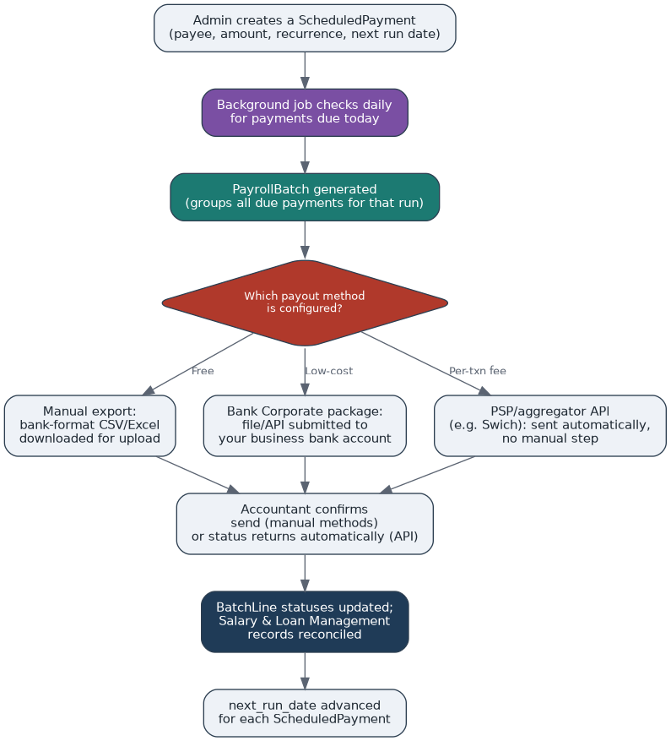
Figure 2 — Scheduled payment lifecycle. The payout method is a per-institute configuration choice, not a code branch.

5. Payout Options for Pakistan
Option | Cost | Automation
Manual bank-file export | Free | ILMA generates a bank-format CSV/Excel each cycle; the accountant uploads it to the institute's own bank's corporate internet banking bulk-transfer tool. No integration work, no API fees — one manual upload per cycle.
Bank's own Corporate Salary package | Often free or a small flat fee per transfer, if the institute holds a business account there | Most Pakistani banks (HBL, UBL, MCB, Meezan, Allied, etc.) offer this for business account holders, running on 1LINK's Bulk 1IBFT rail under the hood. Cheapest semi-automated option — worth a call to the institute's business banking desk.
1LINK Bulk 1IBFT directly | Per-transaction fee per 1LINK's Schedule of Charges; free onboarding; batches up to 5,000 transfers | Built specifically for salary transfers, disbursements and remittances, but 1LINK works with participating banks/FIs, not directly with individual businesses — needs a bank or licensed aggregator to front the integration.
PSP/aggregator API (e.g. Swich and similar) | Per-transaction fee (bank fee + PSP margin) | One integration reaches banks via 1LINK, plus wallets (JazzCash, Easypaisa) and Raast, with real-time tracking. Full API automation from inside ILMA — no manual upload.
None of these rails are literally free at scale — the free tier is the manual bank-file export, which trades automation for zero cost.

6. Recommendation
- Build the scheduling engine now — it's free and the same engine serves every payout method below it.
- Ship the manual bank-file export as the default payout method for MVP — zero cost, gets the feature working immediately.
- Offer the institute's own bank's Corporate Salary package as the first automated upgrade — cheapest automated option, and many institutes may already bank with a provider that offers it.
- Add a PSP/aggregator integration (e.g. Swich) later as a premium, fully hands-off option once payroll volume across institutes justifies the integration effort and per-transaction cost.

7. Open Questions
- Should PayoutMethod be configured once per institute, or selectable per PayrollBatch run (e.g. urgent off-cycle payments via a faster/costlier rail)?
- For the manual export path, what bank-file format(s) need support — a single generic CSV, or per-bank templates?
- Does a failed/bounced BatchLine need an automatic retry, or should it always route to manual review (consistent with the failure-handling pattern in the Mantiq payment routing doc)?
- Should Fee Payment (money coming in) and Payroll (money going out) share the same PayoutMethod/PSP relationship, or be configured independently per institute?

